Hamlet Video Critic Scratch Sheet

Directors

Cimolino | Branagh  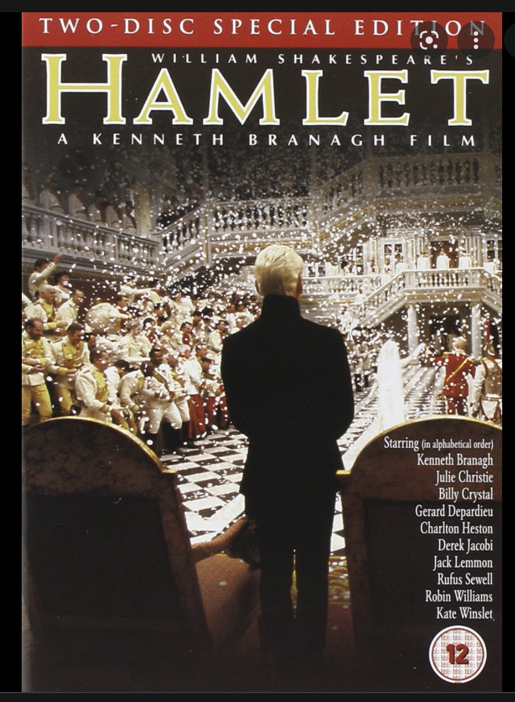 | Doran  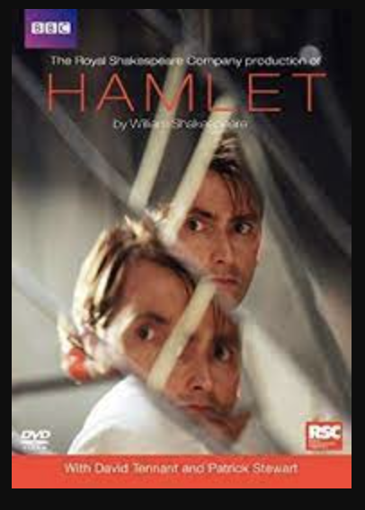 | Almereyda  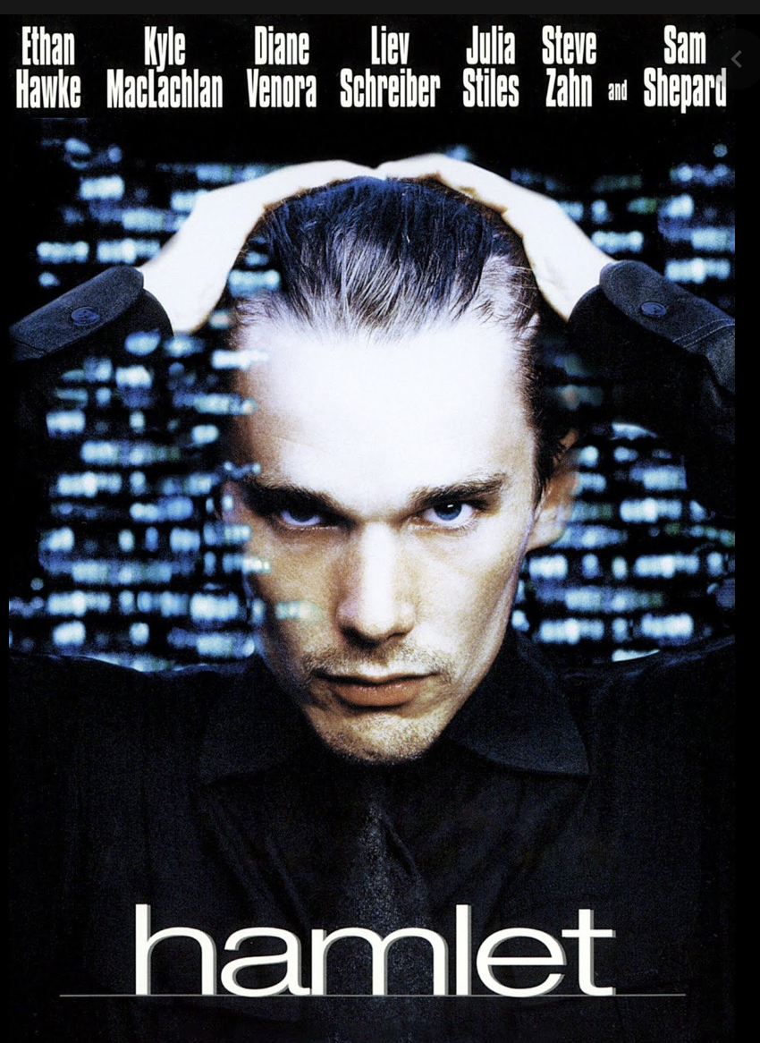 | Gade  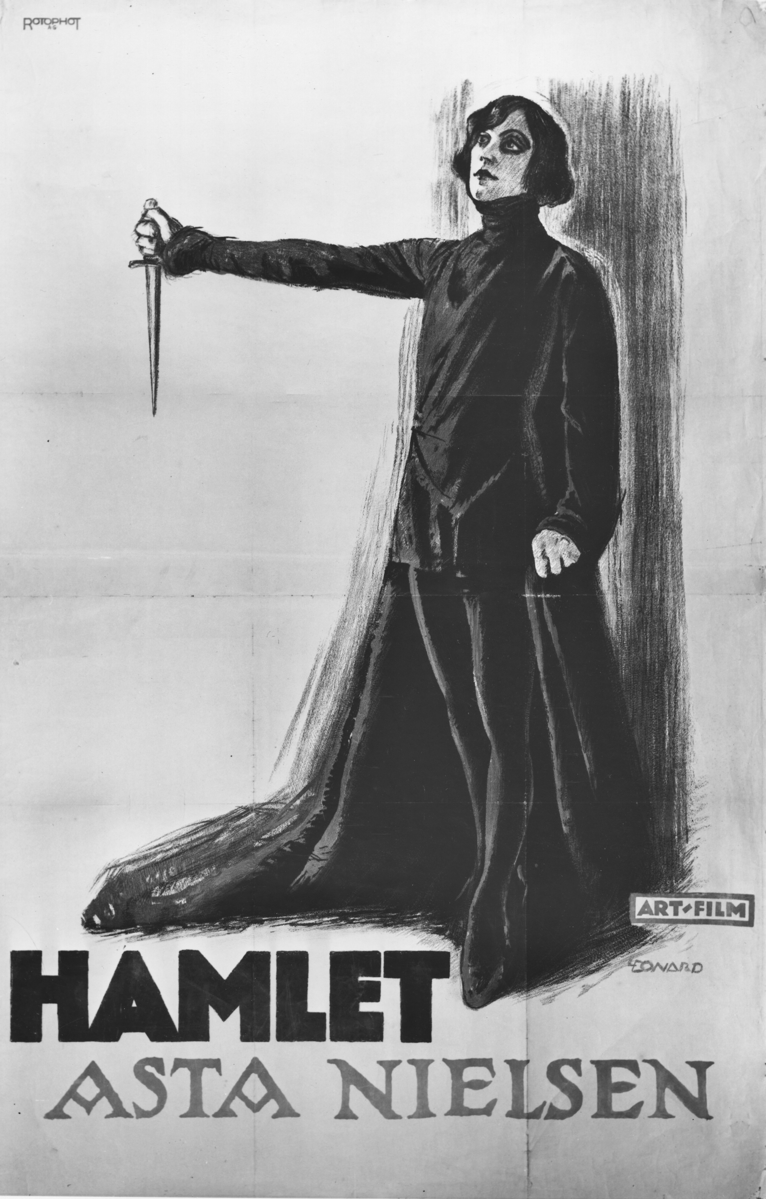

Director | Critic Specialty | Observations and Comments
Screenwriter:
Closely follow the original text and note omissions, additions, pauses, stressed words, and rearrangements.

Cinematographer:
Note and describe camera movement and angles, lighting, etc. While it is not your official job, consider editing as well.

Sound Editor:
Listen for all music, background sounds, sound F/X, etc. Turn away from the screen to do this.

Set and Costume Designer:
Note and describe sets, costumes, props, etc, paying particular attention to colors and symbols.

Actor:
Note and describe specific aspects of the performance, especially accents, subtext, and emphasis of certain words or lines.

